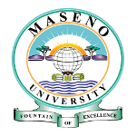
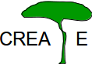
Consortium for Research in East African Tropical Ecosystems

July 4, 2014

DRAFT DOCUMENT

Report on the Second CREATE Workshop

University of Bayreuth, June 29 – July 6, 2014

The following goals were visualized for the second CREATE workshop:
- Initiating communication between key players of Maseno University working on improving livelihoods in the Lake Victoria Basin and the faculty and administration of the University of Bayreuth, as a critical step in expanding collaboration with respect to understanding the impacts and potential management of global change.
- Identification of a palette of “true interests” of UBT faculty interested in cooperative research in Kenya (and together with Maseno University), in order that appropriate local partners can be identified.
- Determine the structure for the Third CREATE Workshop planned at Maseno University in February 2014. Establish a workshop structure that will subsequently facilitate joint research proposals.
- Discuss the long-term goals of collaboration between Maseno University and UBT, and identify components of “win-win” interactions, e.g., determine what steps will lead to added gains through cooperation.

Concrete Outcomes of the Workshop

Discussions carried out both in plenary and individually have led to the following points with respect to future steps in developing the relationship between UBT and Maseno University.

Vision of a Long-term Goal for the Lake Victoria Basin

The jointly promoted activities of CREATE relate to sustainable resource use within the Lake Victoria Basin and practical management of resources in a manner that leads to improved livelihoods of the local populations in this region. The focus of activities is on the linkages between global change, regional response of ecosystems, modifications in available ecosystem services, management to achieve “optimal” provision of ecosystem services, and communication with local stakeholders to achieve management goals. In fact, the focus is on a continual loop in linkages, which should begin with evaluation of existing services and stakeholder interests, examine potential future change, and determine if possible, the most advantageous management strategies.

Growth of the CREATE initiative should lead to the establishment of A Flagship Centre for the Lake Victoria Basin which brings together strengths of the Maseno University, outside university cooperations, and management intiatives of the Lake Basin Authority. Such a center would be important not only to Kenya, but would also serve as an example of integrated and interdisciplinary research for the trans-national communities of the Lake Victoria Basin, given that there is a certain degree of convergence in the natural systems addressed and the potentials for obtaining ecosystem services. Within this Centre, there should be an emphasis and balancing of academic approaches; extension of ecosystem science to social dimensions, economics and multiple scale views; and direct linking of research to planning for sustainability, i.e., it should demonstrate how to effectively carry out environmental problem solving

The mission of such a Flagship Centre would relate to:
Conservation, Informatics and Ecological Modeling of Climate and Land Use Change Impacts: Building understanding to improve livelihoods in the Lake Victoria Basin.

Contributions to the establishment of such a Centre, and the steps conducted along the way, are a cross-cutting initiative which will link together Schools of the Maseno University that are dedicated more to disciplinary foci. The effort should be included into an Internationalization Strategy at both the Maseno University and the University of Bayreuth.

Establishing Individual Partnerships at Third CREATE Workshop

Having assessed the interests of UBT faculty with respect to future research initiatives, a stepwise planning will be carried out, especially during the Third CREATE Workshop in February 2015. The third workshop will include ca. 15 persons from UBT and a slightly larger number from Maseno University and other Kenyan institutions. The intent is to cement individual partnerships, to build interest clusters, and to identify a number of opportunities to write funding proposals.

We will attempt to include a coherent planning of these multiple initiatives, such that larger integrated studies (Forschergruppen, SFB, EU proposals) may become a possibility. For this reason, we intend to encourage thinking in the direction of two geographic locations: 1) the Nzoia River Basin, a 13000 km² social-ecological system of high complexity which embodies a large proportion of the natural systems found in the Lake Victoria Basin, is a major water contributor to the lake, and includes a broad spectrum of livelihoods pursued by 3 million people with two main cultural backgrounds; and 2) the Lambwe Valley as centered on Ruma National Park, an important natural savanna wildlife protection area with rhino introductions and developing management for tourism in Western Kenya.

Themes of the Third CREATE Workshop (foci of future research proposals) that have resulted from current discussions are the following:

The Stakeholders and Ecosystem Services: Both natural ecosystem response and ecosystem service extraction change in a regular fashion along the toposequence within the region from ca. 1500 m to 3500 m above sea level. Workshop participants will gain a clear understanding from the beginning of the interests of stakeholders locally, considering fishing, rice production, sand and stone harvesting, sugar cane and maize production, small farms, reforestation, charcoal production, grazing and livestock raising, etc.

Societal questions: With a new constitution in 2010 and slow enactment of new policies under this framework, questions of devolution, i.e., transfer of decision-making power and policy development to the county level is a major theme in Kenya. Questions related to local involvement in decision-making processes, local, national and global resource protection models and practices, methods for building communication and balancing views and interests between local governing bodies and other stakeholders, and the role of women in the society are major issues. These questions should be investigated in parallel with the potential response of the natural system and included into considerations of resource management.

Economy: Based on understanding of stakeholders and potentials for acquiring ecosystem services, economic limitations on management and change, as well as costs versus gains of management measures (economic efficiency) must be examined. Economic analyses as well as sociological and ecosystem service analyses may address the consequences of policy established under devolution (local management) versus outside influences due to national policy or international markets (impacts on land use, employment and landscape balances).

Spatial Information: The life of a region depends on ecosystem services derived from diverse landscapes. To build the link between natural potentials and subsequent resource use, spatial data is required for the implementation of models that can quantify, for example, agricultural and forest production, water yields and water quality, or nutrient balances and transport. A concentrated effort is required to assemble spatial descriptions of land cover and land use, climate drivers, historical information on river discharge, population, ground water wells, etc. for the Nzoia River Basin (see also IT below). There is a strong need for cooperation here on remote sensing, evaluation of existing maps, hydrological modeling (additionally related to erosion and water quality), and production modeling. Ultimately tools are required to quantify outputs of terrestrial ecosystem services, but also transport to Lake Victoria, and to consider the change in regional dynamics that will accompany major dam construction (strong tieback to economics).

Ecosystem Processes: The collective response of regions as exhibited in watershed outputs depends on processes occurring in individual fields or vegetation stands. Specific knowledge of the dynamics of carbon, water and nutrient balances are required that have only been quantified in small part in the tropical systems that are of importance in the Lake Victoria Basin. Process studies are needed to better understand the inputs and outputs from wetlands, rice paddies, sugar cane and maize fields, natural forest remnants versus reforested areas, and tree plantations. Trade-offs in ecosystem services that result due to promotion of particular plant species should be examined. The choice of plant species in agriculture and reforestation influence economics when large areas are modified.

Exceptional potentials exist within the Nzoia Basin to examine H₂O and CO₂ exchange along the altitudinal (selected locations from the Lake Victoria flood plain to the tropical alpine) and land use (disturbed vs. intact ecosystems) gradients. Potential study locations should be supplemented with sites in Lambwe Valley south of Kisumu, which although outside the basin, is the most advantageous link to natural savanna vegetation and to wildlife tourism. Furthermore, significant equipment installations have already been made, and long-term data sets on basic ecological processes have already been obtained (Huwe, Tenhunen, Otieno et al.).

Multiple uses of isotopic techniques in the assessment of hydrological, nutrient, carbon and trace gas fluxes are visualized. The BayCEER isotope analysis lab is well-instrumented for sample analysis, and cooperation in this regard will open new dimensions for Maseno University.

Health: Water availability and supply, food supply, water borne disease, and parasite habitats must be managed to achieve robust and viable communities in the Lake Victoria Basin. Additionally, there is need to build linkages between laboratory-based investigation of diseases and aspects of their natural occurrence. Global Change may lead to large shifts in occurrence and controls. Such considerations must be built into integrated study of the Nzoia River Basin.

IT: Cooperation was begun during 2011 between UBT and Moi University on IT used in Strategies to Enhance Higher Education – SEED. Moi University is a cooperation partner of Maseno University, is located in close proximity and is within the Nzoia RiverBasin.

A strategy in addition to SEED is required for establishment of a long-term management platform and archiving system for various kinds of scientific environmental observation and measurement data, including contextual data ('metadata') concerning soil, land use, ground water, climate, population, housing, etc. Envisaged data holding structures will support as well as attract scientific modeling studies. Given that multiple languages are important among groups in Kenya for accessing database contents, it is necessary to extend existing solutions (databases with corresponding client software, i.e. user interfaces), towards multiliguality which will allow for providing data alternatively in the various implemented languages. Such solutions have already been realized in several projects at UBT and have found acceptance in a broad community. Use of up-to-date IT in communication with stakeholders (empowerment) is also important.

The Third CREATE Workshop will examine exactly these issues with presentations, with discussions in plenary and among individuals, and by excursions to see directly the systems that are described in the field.

Funding
Based on our discussions the immediate needs relate to mobility within the UBT/Maseno Core Group. An application for workshop funds will be made as soon as possible to BayIntAn / BayFOR (http://www.bayfor.org/de/forschungsfoerderung/bayerisches-hochschulfoerderprogramm-zur-anbahnung-internationaler-forschungskooperationen/foerdersumme.php).
Additionally, a coordinated “proposal package” to support faculty and student mobility will be planned in discussion with DAAD in Nairobi.

Extension of the UBT / Maseno University MOU
The planning described above provides the basis for extension of the current MOU as undertaken on July 4, 2014. A four year extension was signed by President Stefan Leible and by Vice Chancellor Makawiti. The results of the workshop and potentials for future cooperation were discussed in detail, especially in the context of the Bavarian Research Institute for African Studies (BRIAS). In particular, and beyond the themes that were primarily the focus of the 2nd CREATE Workshop, questions related to health sciences and energy provision were put on the agenda as items to explore. Maseno University already has an emphasis on these areas of research and has international research partners involved. A future visit of Vice Chancellor Makawiti to Bayreuth will be dedicated to visiting the partner institutions of BRIAS.

Furthermore, the strongly developed ties of UBT with Moi University were discussed. Moi University is located centrally in the Nzoia River Basin and close to Maseno University. There are many existing links that can be advantageously used to add to joint education programs. In that context, planning will be carried out to include Moi University into the 3rd CREATE Workshop. This will be pursued by a reciprocal visit of Professors Peiffer, Tenhunen and Rambold to Maseno and Moi Universities during September 2014. This visit will lead to the concrete plan for the 3rd CREATE Workshop to be held at Maseno University during the first week of February 2015.

Prof. John Tenhunen
BayCEER (Bayreuth Center for
Ecological and Environmental Research)
Department of Plant Ecology
University of Bayreuth
Germany

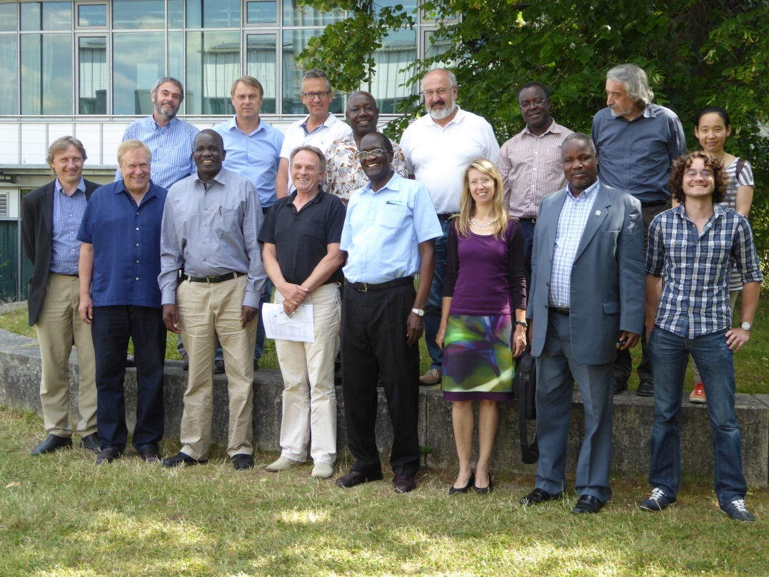

Workshop participants on campus: 1st row left to right R. Debusmann, J. Tenhunen, P. Abok, K. Beck. O. Ahawo, C. Werner, D. Makawiti, S. Arnhold. 2nd row B. Huwe, C. Samimi, S. Peiffer, J. Onyango, G. Gebauer, D. Otieno, G. Rambold, E. Jung (the full participant list is included in the following pages).

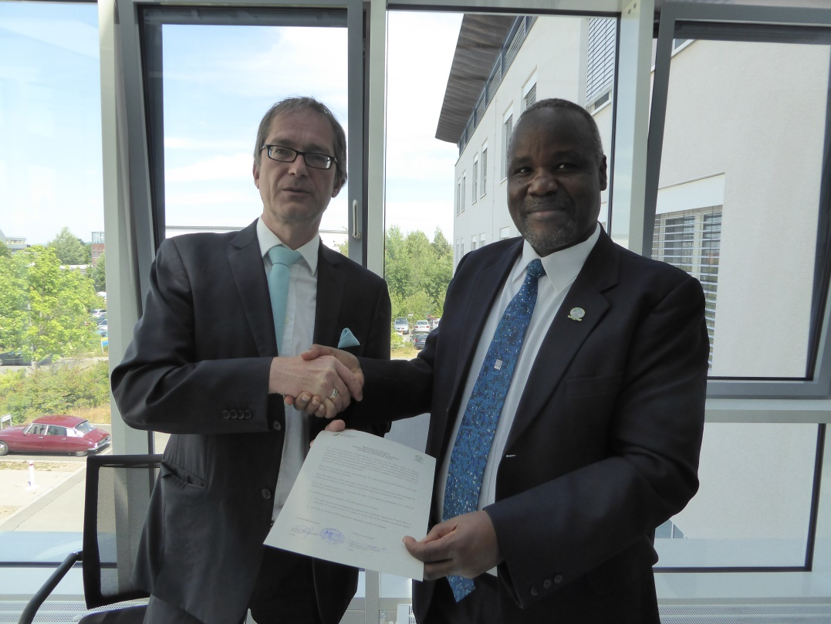

Signing of the four year extension of the UBT / Maseno University Memorandum of Understanding by President Stefan Leible and Vice Chancellor Dominic Makawiti.
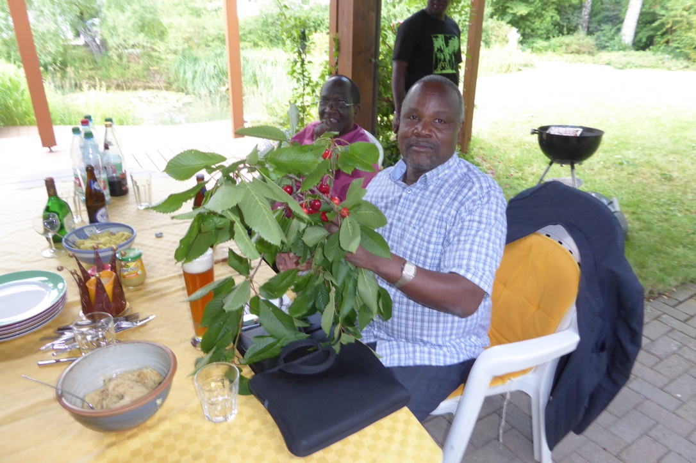

Study by Vice Chancellor Makawiti and Prof. Osmondi Ahawo of new potentials available through cooperation with UBT during a planning and wrap-up session in Eckersdorf.

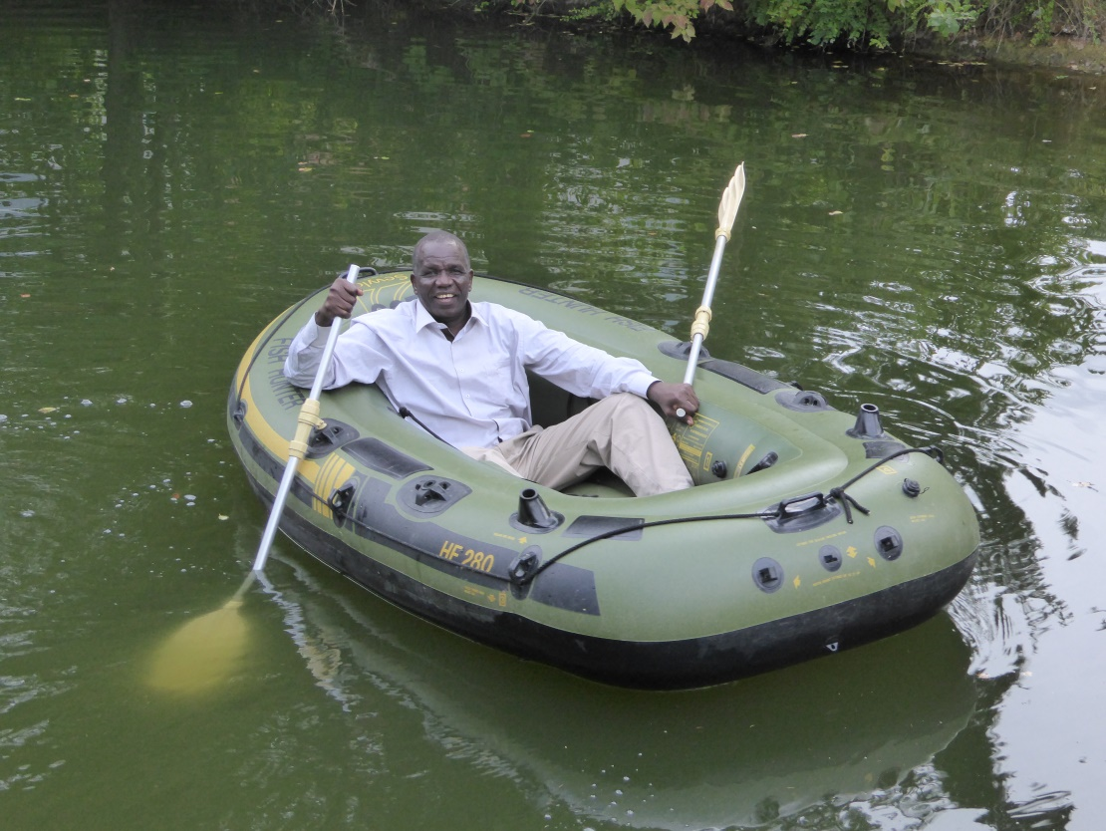

Investigation of lake resources in Eckersdorf by Dr. Peter Abok, Director of Lake Basin Development Authority.

Consortium for Research in East African Tropical Ecosystems

July 7, 2014

Participants of the Second CREATE Workshop

University of Bayreuth, June 29– July 6, 2014

UBT Researchers
Dr. Sebastian Arnhold, sebastian.arnhold@uni-bayreuth.de, +49(0)921-55-4635
Prof. Kurt Beck, kurt.beck@uni-bayreuth.de, +49(0)921-55-4133
Prof. Uli Beisel, uli.beisel@uni-bayreuth.de, +49(0)921–55-4232
Prof. Klaus Ersfeld, klaus.ersfeld@uni-bayreuth.de, +49(0)921-55-2726
Prof. Gerhard Gebauer, gerhard.gebauer@uni-bayreuth.de, +49(0)921-55-2060
Dr. Bärbel Heindl-Tenhunen, baerbel.heindl-tenhunen@uni-bayreuth.de, +49(0)921-55-2572
Prof. Bernd Huwe, Bernd.Huwe@uni-bayreuth.de, +49(0)921-55-2295
Dr. Eun-Young Jung, Eun-Young.Jung@uni-bayreuth.de, +49(0)921 55-2581
Ms. Rose Kimani, +49(0)921-55-5101
Prof. Georg Klute, georg.klute@uni-bayreuth.de, +49(0)921-55-4106
Prof. Thomas Koellner, thomas.koellner@uni-bayreuth.de, +49(0)921-55-2373
Ms. Bora Lee, bora.lee@uni-bayreuth.de, +49(0)921-55-2574, +49(0)176-32260774
Mr. Steve Lindner, SteveLindner@yahoo.de, +49(0)921-55-2575 Mobile: +49(0)178-5321704
Dr. Thanh Nguyen, Thanh.Nguyen@uni-bayreuth.de, +49(0)921-55-2573
Ms. Pamela Omanga, pammyroc1@yahoo.com
Dr. Dennis Otieno, Dennis.Otieno@uni-bayreuth.de, +49(0)921-55-2325
Prof. Stefan Peiffer, s.peiffer@uni-bayreuth.de, +49(0)921-55-2251
Prof. Gerhard Rambold, gerhard.rambold@uni-bayreuth.de, +49 (0)921-55-2453
Dr. Marianne Ruidisch, ruidisch@uni-bayreuth.de, +49(0)921-55-2584
Prof. Cyrus Samimi, cyrus.samimi@uni-bayreuth.de, +49(0)921-55-2237
Prof. John Tenhunen, john.tenhunen@uni-bayreuth.de, +49(0)921-55-2570
Ms. Magdalene Wafula, mnwafula@gmail.com
Prof. Christiane Werner, c.werner@uni-bayreuth.de, +49(0)921-55-2292

Kenyan Guest Scientists
Dr. Peter Abok, kabpaguko@yahoo.com
Prof. Omondi Ahawo, ndagwe@gmail.com, +254 (0)057 351 620-3217
Prof. John Onyango, jconyango@yahoo.com, +254(0)722 659 155
Prof. Dominic Makawiti, dmakawiti@maseno.ac.ke, +254(0)722 513828

UBT Administrative Personnel
President Stefan Leible, praesident@uni-bayreuth.de, +49(0)921-55-6330
Vice President Martin Huber, martin.huber@uni-bayreuth.de, +49(0)921-55-3611
Dr. Arnim Heinemann, arnim.heinemann@uni-bayreuth.de, +49(0)921-55-5240
Dr. Robert Debusmann, robert.debusmann@uvw.uni-bayreuth.de, +49(0)921-55-5206
Mr. Thorsten Parchent, thorsten.parchent@uvw.uni-bayreuth.de, +49 (0)921-55-5319

Department of Plant Ecology Personnel
Ms. Sandra Thomas, Sandra.thomas@uni-bayreuth.de, +49(0)921-55-2571
Ms. Margarete Wartinger, Margarete.Wartinger@uni-bayreuth.de, +49(0)921-55-2572
Mr. Ralf Geyer, Ralf.Geyer@uni-bayreuth.de, +49(0)921-55-2576

