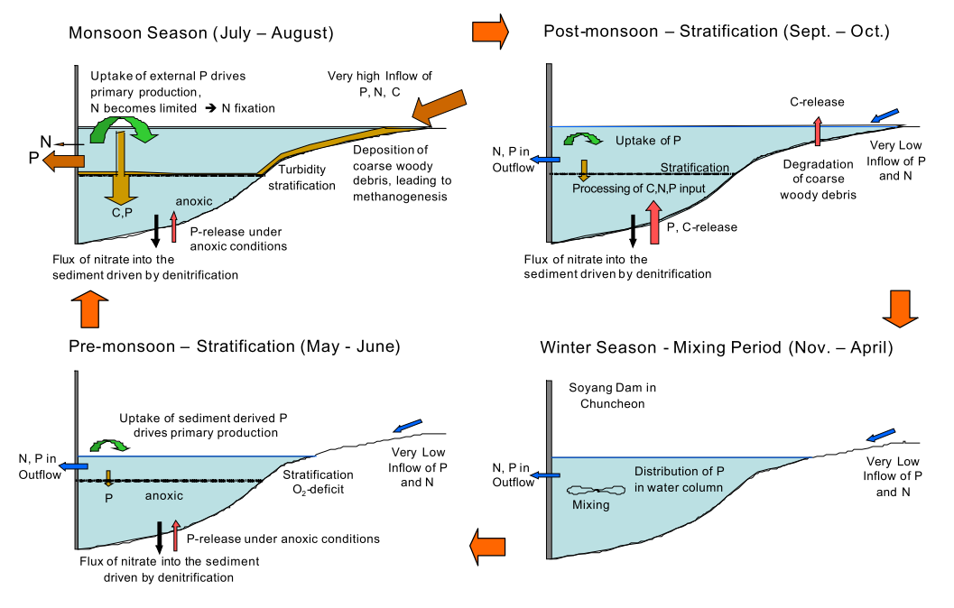
Figure 1. Hypothesized controls on the Soyang Reservoir water quality over an annual cycle.

